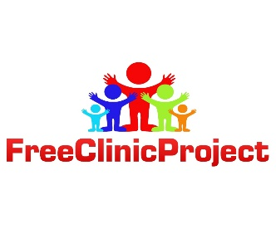  Medical supplies Needed | Holdidays Supplies Drive
Gloves | Trucks
Ace Bandage | Dolls
Alcohol Pads | Toy Cars
Gauze | Art Kits
Children’s Vitamins (Really Need) | Building Blocks
Cold Remedy | Action figures
Allergy Medication | Basket/soccer/footballs
Bandage/ Bandage Wraps | Tote bags
Neomicin | Music players
Neosporin Cream | Puzzles
Blood Pressure Cuffs | Craft sets
Pulse oximeter | Remote Control Cars
Thermometer | Tea sets
Children’s iron vitamin (Really need) | jewelry play sets
Dental Hygiene Products | Teddy Bears
Hot and Cold Packs | Educational Baby toys
Pregnancy Tests | Tote Bags
Vicks | Hair accessories
Burn Relief Gel | Dress up sets
Vitamin C | clothing

